**ANSIBLE AUTOMATION TOOL**

**What is Ansible?**

Ansible is an open source tool that enables automation, configuration, and orchestration of infrastructure .

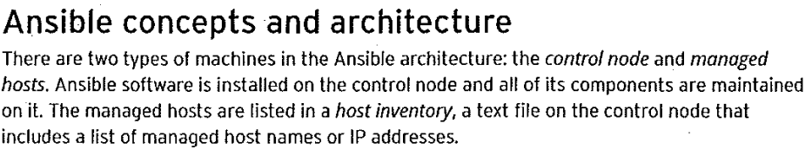

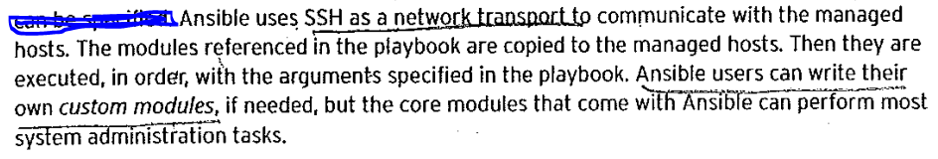

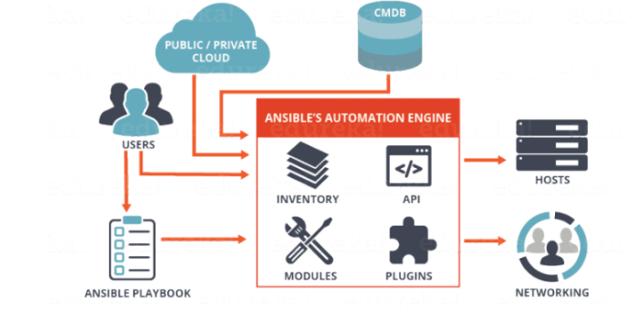

**Ansible Control Node Components:-**

1. **Ansible Configuration File**

Ansible has configuration settigs that defines how it behaves.   
Default configuration files can be overridden by enviroment variables and values defined in configuaration file.  
The default ansible configuration file is “/etc/ansible/ansible.cfg”

1. **Host Inventroy**

The inventory can defined how ansible communicate with managed hosts and it also defines host and group variable values.

The default ansible inventory file is “/etc/ansible/hosts”

1. **Core Modules**

Core modules are the modules that come bundled with ansible.

1. **Custom Modules**

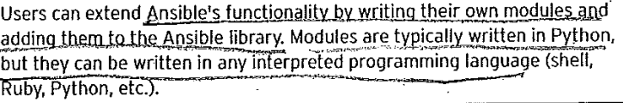

1. **Playbooks**

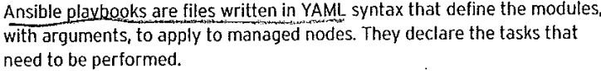

1. **Connection Plugins**

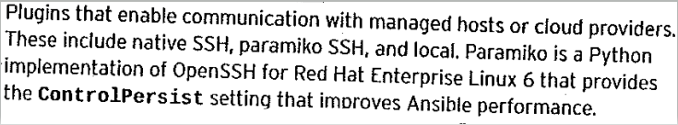

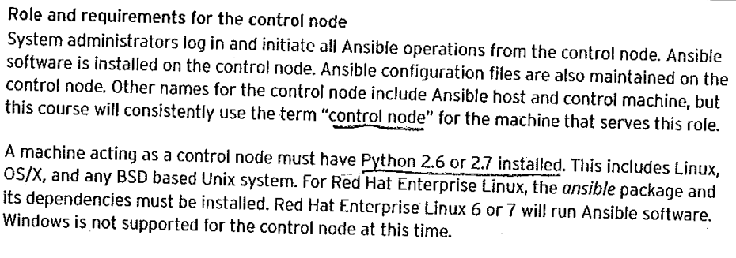

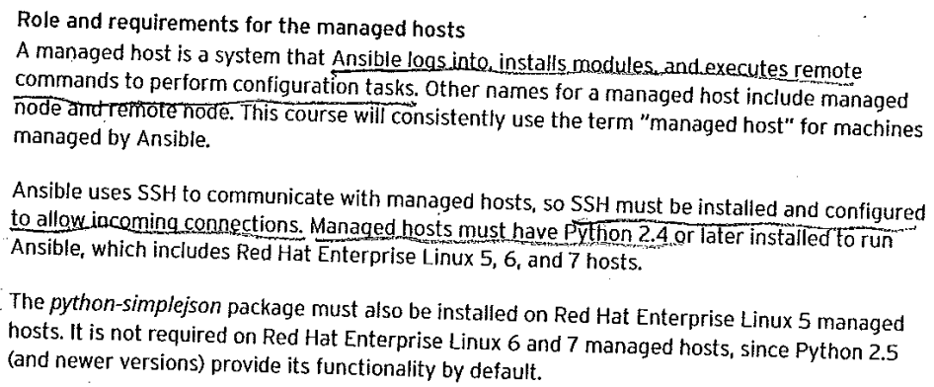

**Ansible Use Cases:-**

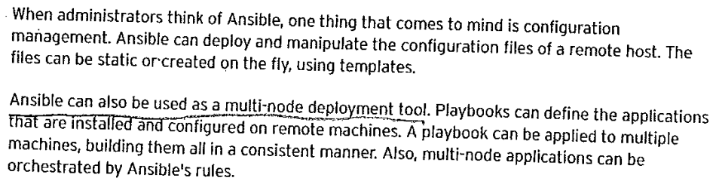

**Remote task execution can also be perforrmeed by Ansible. This can be demonstrated by specifying ad hoc commands on the command line, causing Ansible to execute them on remote hosts.**

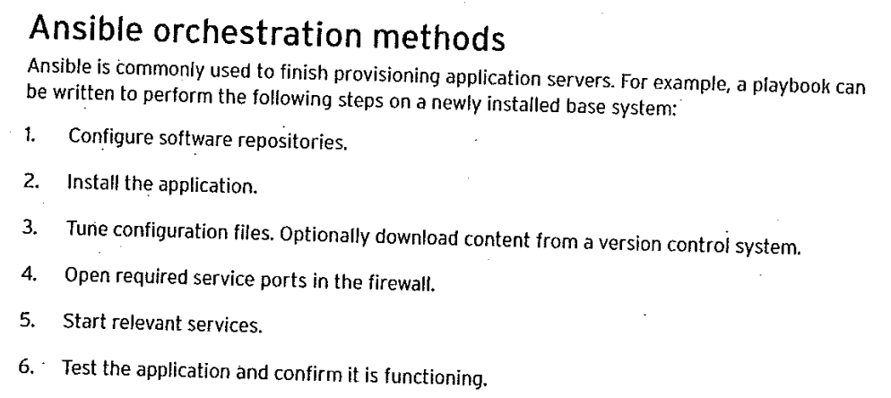

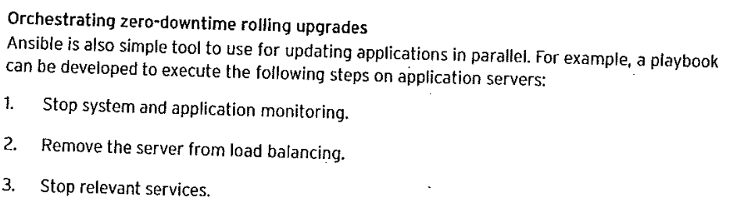

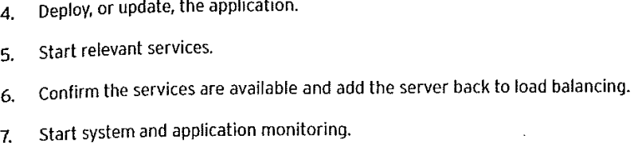

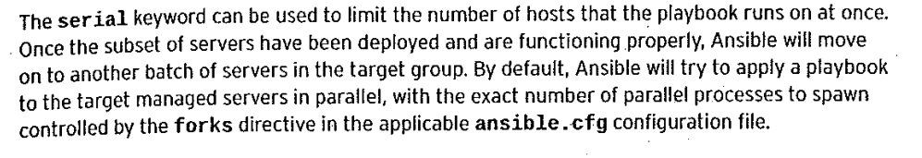

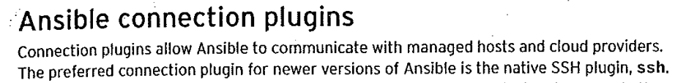

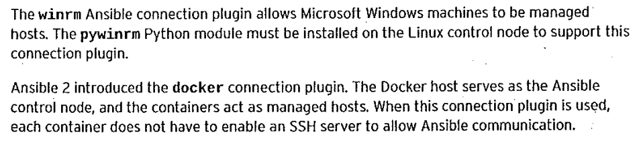

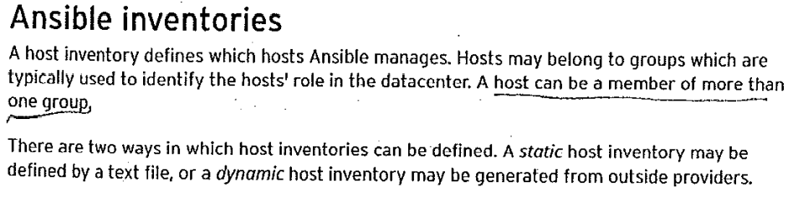

**Explain more detail by creating ansible inventory file.**

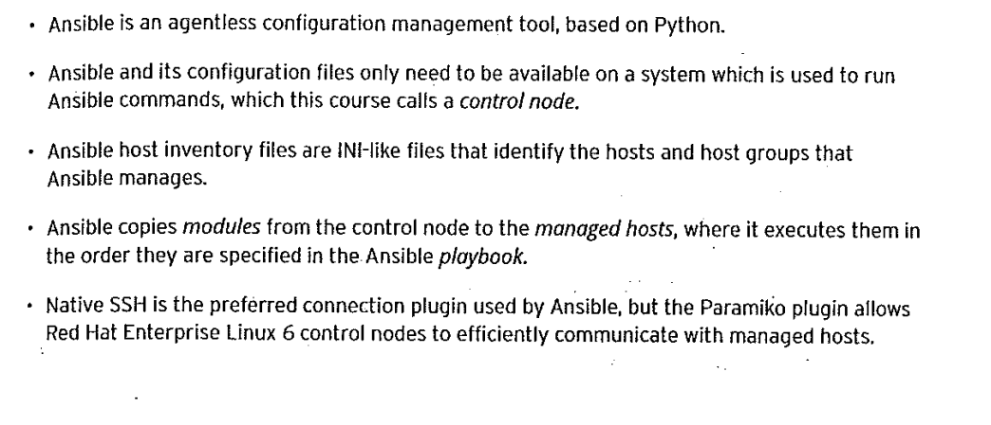

**Package Name: ansible**